**MongoDB Assignment 2**

**Questions:**

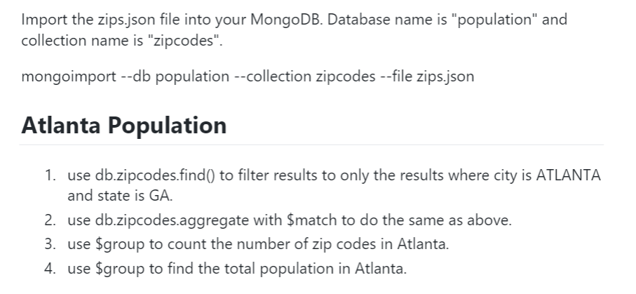

**Comments & Results:**

**db.zipcodes.find({"city":"ATLANTA","state":"GA"}).pretty().count()**

31

> **db.zipcodes.aggregate([{$match:{city:"ATLANTA",state:"GA"}},{$count:"Totalcount"})**

{ "Totalcount" : 31 }

**db.zipcodes.aggregate([{$match:{"city":"ATLANTA"}},{$group:{_id:"$city","count":{$sum:1}}}])**

{ "_id" : "ATLANTA", "count" : 41 }

**db.zipcodes.aggregate([{$match:{city:"ATLANTA"}},{$group:{_id:"$city",population:{$sum:"$pop"}}}])**

{ "_id" : "ATLANTA", "population" : 630046 }

**db.zipcodes.find({"city":"ATLANTA","state":"GA"}).pretty()**

{

"_id" : "30303",

"city" : "ATLANTA",

"loc" : [

-84.388846,

33.752504

],

"pop" : 1845,

"state" : "GA"

}

{

"_id" : "30305",

"city" : "ATLANTA",

"loc" : [

-84.385145,

33.831963

],

"pop" : 19122,

"state" : "GA"

}

{

"_id" : "30306",

"city" : "ATLANTA",

"loc" : [

-84.351418,

33.786027

],

"pop" : 20081,

"state" : "GA"

}

{

"_id" : "30307",

"city" : "ATLANTA",

"loc" : [

-84.335957,

33.769138

],

"pop" : 16330,

"state" : "GA"

}

{

"_id" : "30308",

"city" : "ATLANTA",

"loc" : [

-84.375744,

33.771839

],

"pop" : 8549,

"state" : "GA"

}

{

"_id" : "30309",

"city" : "ATLANTA",

"loc" : [

-84.388338,

33.798407

],

"pop" : 14766,

"state" : "GA"

}

{

"_id" : "30310",

"city" : "ATLANTA",

"loc" : [

-84.423173,

33.727849

],

"pop" : 34017,

"state" : "GA"

}

{

"_id" : "30311",

"city" : "ATLANTA",

"loc" : [

-84.470219,

33.722957

],

"pop" : 34880,

"state" : "GA"

}

{

"_id" : "30312",

"city" : "ATLANTA",

"loc" : [

-84.378125,

33.746749

],

"pop" : 17683,

"state" : "GA"

}

{

"_id" : "30313",

"city" : "ATLANTA",

"loc" : [

-84.39352,

33.76825

],

"pop" : 8038,

"state" : "GA"

}

{

"_id" : "30314",

"city" : "ATLANTA",

"loc" : [

-84.425546,

33.756103

],

"pop" : 26649,

"state" : "GA"

}

{

"_id" : "30315",

"city" : "ATLANTA",

"loc" : [

-84.380771,

33.705062

],

"pop" : 41061,

"state" : "GA"

}

{

"_id" : "30316",

"city" : "ATLANTA",

"loc" : [

-84.333913,

33.721686

],

"pop" : 34668,

"state" : "GA"

}

{

"_id" : "30317",

"city" : "ATLANTA",

"loc" : [

-84.31685,

33.749788

],

"pop" : 16395,

"state" : "GA"

}

{

"_id" : "30318",

"city" : "ATLANTA",

"loc" : [

-84.445432,

33.786454

],

"pop" : 53894,

"state" : "GA"

}

{

"_id" : "30319",

"city" : "ATLANTA",

"loc" : [

-84.335091,

33.868728

],

"pop" : 32138,

"state" : "GA"

}

{

"_id" : "30324",

"city" : "ATLANTA",

"loc" : [

-84.354867,

33.820609

],

"pop" : 15044,

"state" : "GA"

}

{

"_id" : "30326",

"city" : "ATLANTA",

"loc" : [

-84.358232,

33.848168

],

"pop" : 125,

"state" : "GA"

}

{

"_id" : "30327",

"city" : "ATLANTA",

"loc" : [

-84.419966,

33.862723

],

"pop" : 18467,

"state" : "GA"

}

{

"_id" : "30329",

"city" : "ATLANTA",

"loc" : [

-84.321402,

33.823555

],

"pop" : 17013,

"state" : "GA"

}

**Questions:**

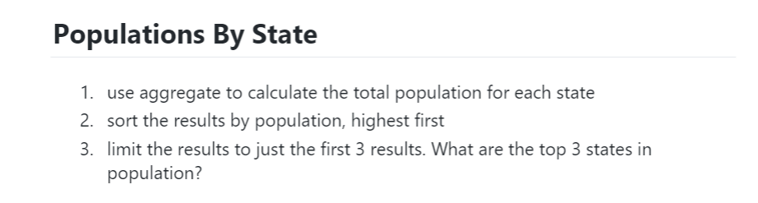

**Comments & Results:**

**db.zipcodes.aggregate([{$group:{_id:{state:"$state"},population:{$sum:"$pop"}}},{$sort:{"population":-1}}])**

{ "_id" : { "state" : "CA" }, "population" : 29754890 }

{ "_id" : { "state" : "NY" }, "population" : 17990402 }

{ "_id" : { "state" : "TX" }, "population" : 16984601 }

{ "_id" : { "state" : "FL" }, "population" : 12686644 }

{ "_id" : { "state" : "PA" }, "population" : 11881643 }

{ "_id" : { "state" : "IL" }, "population" : 11427576 }

{ "_id" : { "state" : "OH" }, "population" : 10846517 }

{ "_id" : { "state" : "MI" }, "population" : 9295297 }

…continuess

**db.zipcodes.aggregate([{$group:{_id:{state:"$state"},population:{$sum:"$pop"}}},{$sort:{"population":-1}},{$limit:3}])**

{ "_id" : { "state" : "CA" }, "population" : 29754890 }

{ "_id" : { "state" : "NY" }, "population" : 17990402 }

{ "_id" : { "state" : "TX" }, "population" : 16984601 }

**Questions:**

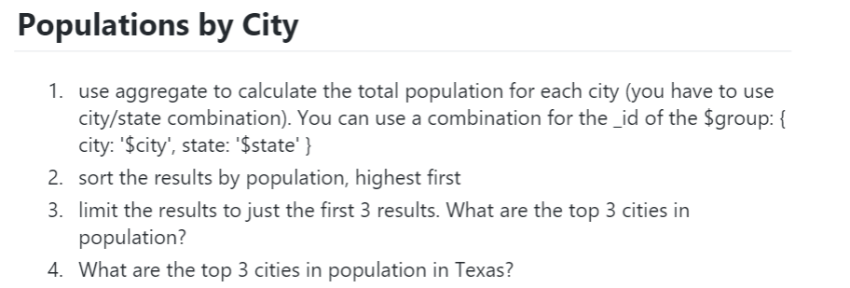

**Comments & Results:**

**db.zipcodes.aggregate([{$group:{_id:{city:"$city",state:"$state"},population:{$sum:"$pop"}}},{$sort:{"population":-1}}])**

{ "_id" : { "city" : "CHICAGO", "state" : "IL" }, "population" : 2452177 }

{ "_id" : { "city" : "BROOKLYN", "state" : "NY" }, "population" : 2300504 }

{ "_id" : { "city" : "LOS ANGELES", "state" : "CA" }, "population" : 2102295 }

{ "_id" : { "city" : "HOUSTON", "state" : "TX" }, "population" : 2095918 }

{ "_id" : { "city" : "PHILADELPHIA", "state" : "PA" }, "population" : 1610956 }

{ "_id" : { "city" : "NEW YORK", "state" : "NY" }, "population" : 1476790 }

.....continues

**db.zipcodes.aggregate([{$group:{_id:{city:"$city",state:"$state"},population:{$sum:"$pop"}}},{$sort:{"population":-1}},{$limit:3}])**

{ "_id" : { "city" : "CHICAGO", "state" : "IL" }, "population" : 2452177 }

{ "_id" : { "city" : "BROOKLYN", "state" : "NY" }, "population" : 2300504 }

{ "_id" : { "city" : "LOS ANGELES", "state" : "CA" }, "population" : 2102295 }

**Questions:**

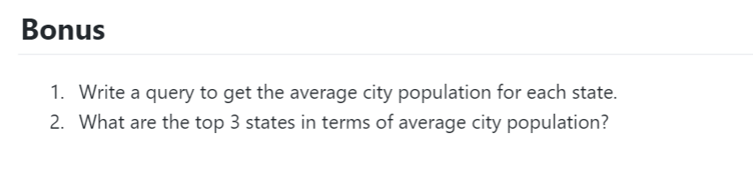

**Comments & Results:**

**db.zipcodes.aggregate([{$group:{_id:{state:"$state"},avg_population:{$avg:"$pop"}}},{$sort:{"avg_population":-1}}])**

{ "_id" : { "state" : "DC" }, "avg_population" : 25287.5 }

{ "_id" : { "state" : "CA" }, "avg_population" : 19627.236147757256 }

{ "_id" : { "state" : "FL" }, "avg_population" : 15779.407960199005 }

{ "_id" : { "state" : "RI" }, "avg_population" : 14539.391304347826 }

{ "_id" : { "state" : "NJ" }, "avg_population" : 14315.162962962962 }

{ "_id" : { "state" : "HI" }, "avg_population" : 13852.8625 }

{ "_id" : { "state" : "AZ" }, "avg_population" : 13574.918518518518 }

...continuee

**db.zipcodes.aggregate([{$group:{_id:{state:"$state"},avg_population:{$avg:"$pop"}}},{$sort:{"avg_population":-1}},{$limit:3}])**

{ "_id" : { "state" : "DC" }, "avg_population" : 25287.5 }

{ "_id" : { "state" : "CA" }, "avg_population" : 19627.236147757256 }

{ "_id" : { "state" : "FL" }, "avg_population" : 15779.407960199005 }